**AZURE APP SERVICE**

**Introduction:**

Azure App Service is a platform that helps us to run web applications, mobile back ends, and RESTful APIs without worrying about managing the underlying infrastructure. Azure App Service is a fully managed Platform as a Service (PaaS) offering from Microsoft Azure. It is a powerful web hosting service that takes care of all the heavy lifting for you, so can focus on creating great applications.

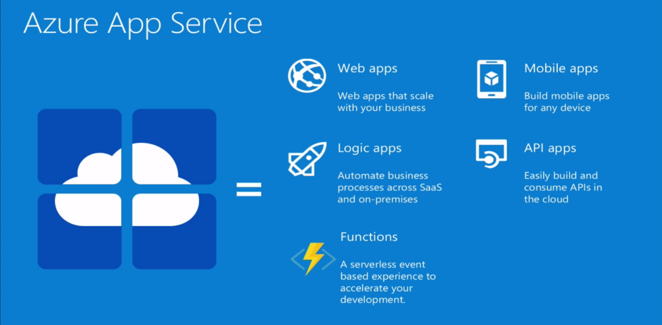

App Service supports a variety of web stacks: .NET, Java (in Java SE, Tomcat, and JBoss flavors), Node.js, Python, and PHP, and can run them on both Windows and Linux. Or, if your app is containerized, you can just deploy it as a custom container.

**Use of Azure App Service:**

It's an excellent choice for students, small businesses, startups, and enterprises alike, offering a range of features tailored to diverse needs.

1. **Benefits for Students:**

Azure App Service provides several advantages specifically designed for students:

* Free Access: Students can take advantage of the Azure for Students Starter program, which offers free access to a variety of Azure services, including Azure App Service, without requiring a credit card.
* IDE Support: Purpose-built deployment tools are available for popular Integrated Development Environments (IDEs) such as Visual Studio, Visual Studio Code, IntelliJ, and Eclipse, making it easier to develop and deploy applications.
* User-Friendly: Azure App Service allows students to run their applications without needing experience in infrastructure management, simplifying the development process.
* Learning Resources: A wealth of tutorials and guides are available to help students get started and deepen their understanding of cloud application development.

1. **Benefits for Small Businesses and Startups:**

Cost-Effective and Scalable:

* Pay-as-You-Go: Only pay for the resources you use, allowing you to manage budgets effectively.
* Automatic Scaling: Scale your applications up or down based on demand, ensuring optimal performance during peak times without manual intervention.

Rapid Deployment and Development:

* Quick Launch: Deploy production-ready applications in minutes, accelerating time-to-market.
* Command-Line Tools: Utilize familiar tools like Azure CLI, Azure Developer CLI, Maven, and Gradle for streamlined deployment processes.

Integrated Security and Compliance:

* Built-in Security Features: Protect your applications with features like firewalls, intrusion detection systems, and web application firewalls (WAFs).
* Compliance Standards: Adheres to industry-standard certifications such as SOC 2, ISO 27001, and HIPAA, ensuring your applications meet regulatory requirements.

Startup-Friendly Programs:

* Azure for Startups Founders Hub: Access up to $150,000 in Azure credits, along with benefits like GitHub Enterprise, OpenAI access, and LinkedIn services at no cost.

1. **Enterprise Benefits:**

* High Availability: 99.95% uptime SLA with built-in load balancing and auto-scaling.
* Isolation and Security: App Service Environment (ASE) provides a fully isolated, highly scalable, and secure environment for running Azure App Service apps in your own virtual network.
* Compliance and Governance: Supports compliance with various regulatory standards and integrates with Azure Policy for governance.
* Integrated Monitoring: Azure Monitor and Application Insights offer deep visibility into application performance and health.

**Key Features:**

* Multi-Language Support: Supports .NET, Java, Python, Node.js, PHP, and custom containers.
* Integrated CI/CD: Seamless integration with Azure DevOps, GitHub, and Bitbucket for continuous integration and deployment.
* Global Reach: Deploy applications across Azure's global network of data centers.
* Built-in Security: Features like SSL/TLS, authentication, and authorization.
* Compliance: Adheres to industry standards and certifications.

**Use Cases:**

* Web Applications: Host scalable and secure web applications.
* APIs: Develop and deploy RESTful APIs with high availability.
* Mobile Backends: Provide backend services for mobile applications.
* Microservices: Implement microservices architectures with container support.